******OFFICE OF THE PRINCIPAL**

**JANATA COLLEGE SERFANGURI**

P.O.- SERFANGURI, - 783346 DIST.- KOKRAJHAR, BTR. (ASSAM)

**M-94350-26695, 0361-291905, e-mail:** [**principal_jcs@rediffmail.com**](mailto:principal_jcs@rediffmail.com) **:: Website:** [**www.janatacollege.co.in**](http://www.janatacollege.co.in/)

Letter No. JCS/SUM/VAC/2025/01 Date.30/06/2025

From,

***Mr. Bitoray Brahma, M.A.*** Principal, i/c

**NOTICE**

This is to inform all the teaching staff, and students of Janata College, Serfanguri that the classes shall remain closed for **Summer Vacation** with effect from **1st July to 30th July 2025**, as per the academic calendar and notification circulated by **Bodoland University**. Accordingly, all students and faculty members are requested to turn up to the college for their respected duties from 31st July 2025 after the vacation.

However, as for the non-teaching staff the normal duty of official works will continue as usual throughout the summer vacation.

Normal classes will resume from **31st July 2025 (Thursday)**.

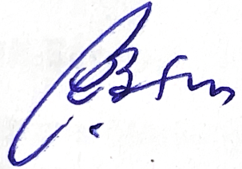

**Principal**  
Janata College, Serfanguri

